Poach a Whole Chicken for an Easy Meal (Or Several)

<https://www.thespruce.com/poach-a-whole-chicken-995345>

BY [DANILO ALFARO](https://www.thespruce.com/danilo-alfaro-994916)

Updated 04/12/17

* SHARE Share
* PIN Pin
* EMAIL Email

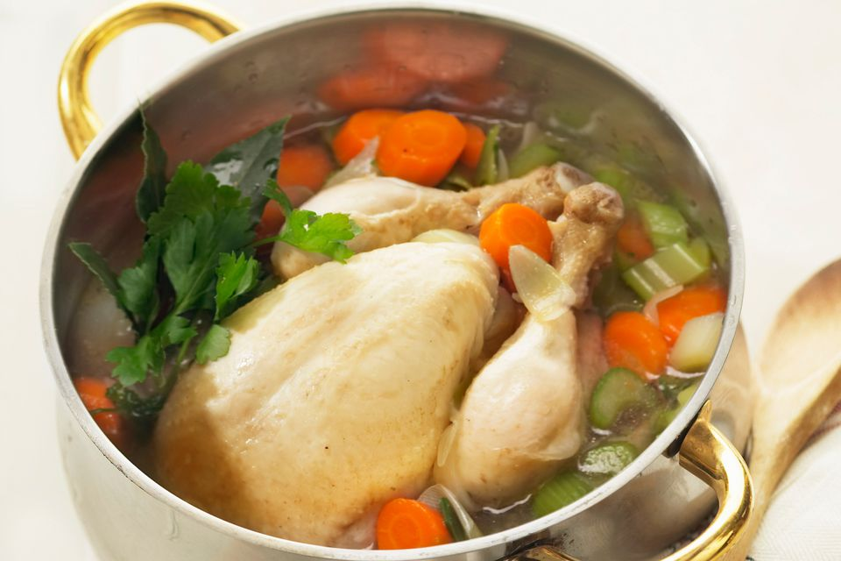

Philippe Desnerck / Getty Images

When you poach a chicken, you're actually doing two things: One, you're making a delicious poached chicken. That's obvious. But two, you're also making a savory [chicken broth you can use](https://www.thespruce.com/recipes-with-chicken-stock-or-broth-995375) in all kinds of wonderful recipes. Lucky you!

Poaching a chicken is a great way to make an easy and wholesome family meal. And because there's no added fat, a poached chicken is a really healthy meal as well. (Or several meals.)

You can pull off the cooked meat and use it in casseroles, chicken salad, chicken enchiladas, chicken pot pie, or any number of pasta dishes. Indeed, the happy truth is that once you've poached a chicken, you're only minutes away from making homemade chicken noodle soup.

The following steps describe how to poach a whole chicken. You'd use a slightly different method if you were only going to [poach the chicken breasts](https://www.thespruce.com/how-to-poach-chicken-breasts-995346).

Poaching a Chicken

1. To begin poaching your chicken, first take a peek to see if your bird has that little bag of [giblets](https://www.thespruce.com/what-are-giblets-995697) in the body cavity. They don't usually, but it's worth checking just in case. And if it's there, remove it.
2. Rinse the chicken under cold running water and let it drain for about five minutes. If you happen to be using an air-chilled chicken, you can skip the rinsing step.
3. While that's happening, chop up an onion, a couple of carrots and two or three celery stalks.
4. Now, transfer the chicken to a large pot. Add the chopped onion, carrots and celery, along with a tablespoon of whole peppercorns; a clove of garlic (peeled and crushed) or two; a [bay leaf](https://www.thespruce.com/what-is-a-bay-leaf-995576) and some [fresh herbs](https://www.thespruce.com/best-flavored-butter-recipes-2098270). My favorite way to do this poached chicken is with a sprig or two of fresh sage, although fresh thyme, rosemary, marjoram, oregano, tarragon or even fresh parsley would also be terrific.
5. Now, cover the chicken with water, add a tablespoon of [Kosher salt](https://www.thespruce.com/kosher-salt-questions-answered-995959), and bring it to a boil. Then lower to a simmer, cover with a tight-fitting lid and cook for about an hour and twenty minutes. Note that a simmer means somewhere between 180–200F. You'll see a few bubbles rising up gently, but you don't want it any more vigorous than that.
6. After about an hour, you can add some new potatoes, red potatoes or Yukon Gold potatoes, cut up into chunks. Some turnips, peeled and diced, can also be added at this point if you desire.
7. After the full hour and twenty minutes, turn off the heat, remove the chicken and transfer it to some sort of big roasting pan, a [baking sheet](https://www.amazon.com/Vollrath-5314-Wear-Ever-Sheet-1-inch/dp/B0001MS3P6?tag=aboutcom02thespruce-20) or even a large bowl to cool for about twenty minutes. Save the broth! It's liquid gold, full of flavor and body.
8. When the chicken is cool enough to handle, you can pull off all the meat, using a fork to get off the trickier bits. And once that's done, you can even resimmer the carcass to [make a lovely chicken stock](https://www.thespruce.com/chicken-stock-recipe-996161).

Using Poached Chicken Meat

Alternately, you could let the poached chicken cool for about five minutes and then just pull it apart into the main eight pieces (two each of breast, thigh, drumstick and wing) and serve with the broth and vegetables.

Then later you can strip the remaining meat off the carcass.

If you wanted to, you could simmer some egg noodles in the broth while you're pulling the meat off the chicken. Then add the meat to bowls along with the veggies, broth and noodles for a delicious chicken noodle soup. If you're doing noodles, you may want to skip the potatoes, but the turnips will really make a beautiful chicken soup.

Finally, you can strain and cool the broth and use it for making sauces, soups, rice, risotto, or basically anything you'd use chicken stock for. Here are [10 ways to use chicken stock](https://www.thespruce.com/recipes-with-chicken-stock-or-broth-995375).